

International School

**Capstone Project 1**

CMU-CS450

**Project Proposal Document**

**Version 1.0**

**Date:** 21/08/2022

**Craft Village Pollution Monitor System**

**Submitted by**

**Ca, Van Cong Le**

**Huy, Bui Duc**

**Phuc, Hua Hoang**

**Trung, Nguyen Thanh**

**Approved by**

**Ph.D. Nguyen Thanh Binh**

**Proposal Review Panel Representative:**

Name Signature Date

**Capstone Project 1 - Mentor:**

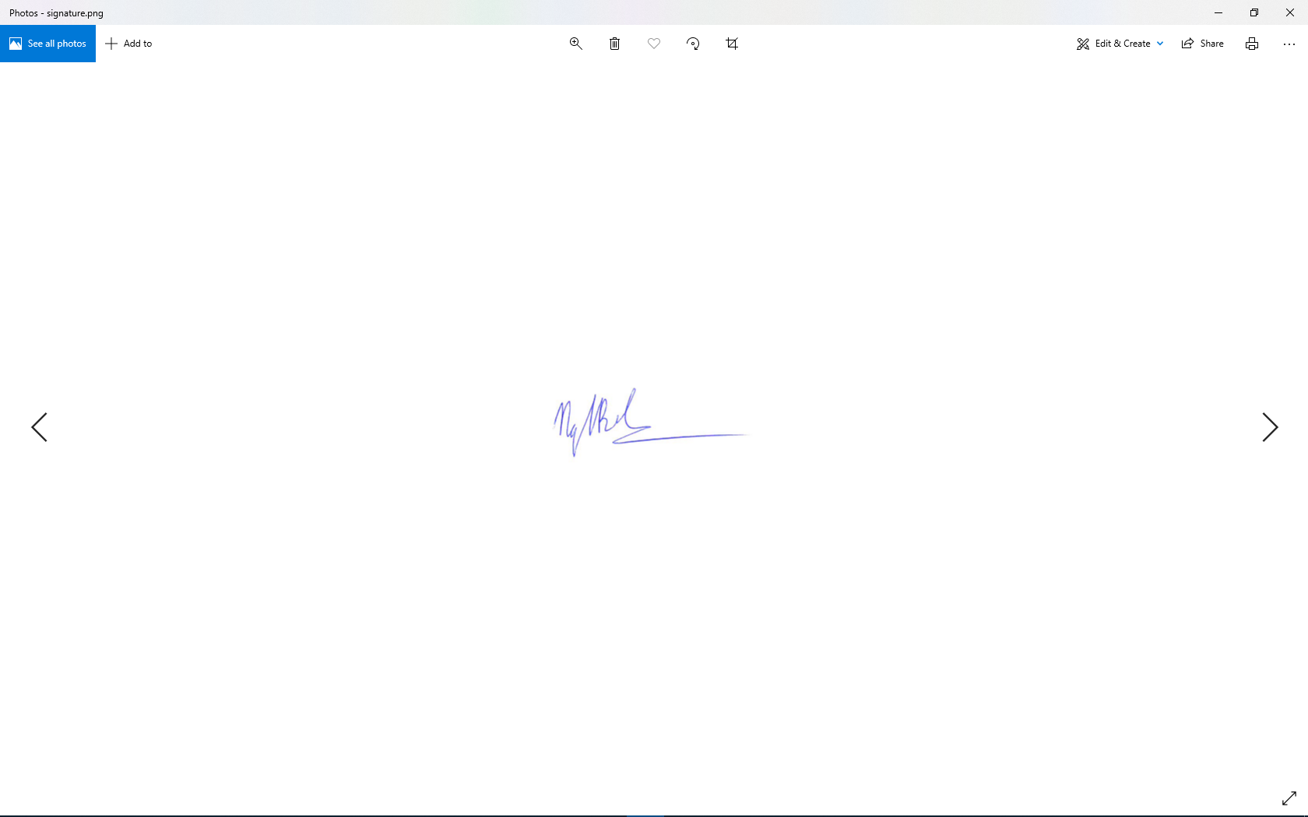

Name Signature Date

**PROJECT INFORMATION**

|  |  |  |  |
| --- | --- | --- | --- |
| **Project acronym** | CVPMS | | |
| **Project Title** | Craft Village Pollution Monitor System | | |
| **Start Date** | 22/08/2022 | **End Date** | 07/12/2022 |
| **Lead Institution** | International School, Duy Tan University | | |
| **Project Mentor** | Ph.D. Thanh Binh, Nguyen | | |
| **Scrum master / Project Leader & contact details** | Ca, Van Cong Le  *Email:* cascabusiness@gmail.com  *Tel:* 0352707895 | | |
| **Partner Organization** |  | | |
| **Project Web URL** | [*https://github.com/Casca113s2/craft-village-pollution-monitor-system*](https://github.com/Casca113s2/craft-village-pollution-monitor-system) | | |
| **Team members** | **Name** | **Email** | **Tel** |
| 25211207666 | Ca, Van Cong Le | [cascabusiness@gmail.com](http://cascabusiness@gmail.com) | 0352707895 |
| 25211215894 | Huy, Bui Duc | [duchuyltt122@gmail.com](http://duchuyltt122@gmail.com) | 0818648090 |
| 25211204084 | Phuc, Hua Hoang | [phuchuho0402@gmail.com](http://phuchuho0402@gmail.com) | 0905639682 |
| 25211215133 | Trung, Nguyen Thanh | [nguyenttrung2601@gmail.com](http://nguyenttrung2601@gmail.com) | 0774496838 |

DOCUMENT NAME

|  |  |  |  |
| --- | --- | --- | --- |
| **Document Title** | Project Proposal Document | | |
| **Author(s)** | All team members | | |
| **Date** | 21/08/2022 | **File Name** | C1SE.06_CVPMS_Project-Proposal-Document_v1.0.docx |

REVISION HISTORY

| **Version** | **Date** | **Comments** | **Author** | **Approval** |
| --- | --- | --- | --- | --- |
| 1.0 | 21/08/2022 | Create documents | All team members |  |

**Table Of Contents**

1. Introduction 6

1.1. Purpose 7

1.2. Scope 8

2. Problem Definition 8

2.1. Project Requirement 8

2.2. Proposed Solutions 9

2.3. Core Technology 10

2.3.1. Location-based Service 10

2.3.2. Image Classification 12

2.4. Technical Constraints 13

3. Current Status of Art 15

3.1. Advantages 15

3.2. Disadvantages 15

4. Engineering Approach 16

4.1. System Context Overview 16

4.2. System Context Description 16

5. Tasks and Deliverables 17

5.1. Tasks and Scope 17

5.2. Deliverables 17

6. Project Management 18

6.1. Scrum definition 18

6.1.1. Scrum description 18

6.1.2. The artifacts 19

6.1.3. Process 19

6.2. Masterplan 21

6.3. Cost/Budget For Project 22

7. Project Contraints 23

8. Conclusion 25

9. References 26

10. Attachment 26

**Table Of Figures**

**Figure 1.** Bat Trang pottery village 6

**Figure 2.** Architecture of the Location Based Services 10

**Figure 3.** Building Data Block 12

**Figure 4.** Detect Pollution Using Multi-Class Classification. 13

**Figure 5.** Detect Pollution Using Multi-Label Classification. 13

**Figure 6.** System Context Diagram 16

**Figure 7.** Scrum Framework at a glance 19

**Table Of Tables**

**Table 1.** Master Plan 21

**Table 2.** Total cost estimate 22

**Table 3.** Cost detail 22

**Table 4.** Project constraints 23

# Introduction

According to the newest statistics from JICA, in collaboration with the Ministry of Agriculture and Rural Development, there are currently 1450 craft villages distributed nationwide in 58 provinces and cities. The Red River Delta is the most crowded area with about 800 craft villages. Most of them are concentrated in all major provinces such as Ha Tay with 280 villages, Thai Binh with 187 villages, Bac Ninh with 59 villages, ...etc. The types of craft villages are very diverse from silk and leather goods to construction materials, ceramics, and porcelain. The craft villages are the place to attract the local labor force, create jobs for laborers in society, and contribute to improving the lives of people.[1]



**Figure 1.** Bat Trang pottery village

However, the disadvantage/bad side of the development is that most of Vietnam's craft villages were and are now being polluted in three forms: water pollution; waste pollution, and air (emissions) pollution. According to the 2009 National Environment Report of the Ministry of Natural Resources and Environment, the survey results in 52 craft villages showed that 46% of craft villages were seriously polluted, 27% were in medium pollution, and 27% were mild pollution. Currently, the environmental quality in most craft villages does not meet the standards, causing laborers to be exposed to health harmful risks, including 95% from dust, 85.9% from heat, and 59.6% from chemicals.[1] One of the main reasons for this happening is the lack of overseeing the pollution from the craft village and the tools that are necessary for people of all ages to take part in protecting the environment. Based on the urgent requirements to have an effective way to monitor the pollution of the craft villages, we would like to do the topic "Building an application that allows everyone to monitoring pollution from craft villages".

## Purpose

* Easy to use:
  + Any person who knows how to use a smartphone can use the application to conduct a pollution survey easily.
  + Support a wide range of ages (from 12 to 65).
* Quick and effective:
  + Automate operations that previously had to be done manually.
  + Perform tasks quickly and accurately by using AI.
* Accurate and complete:
  + Capable of controlling, synthesizing fully accurately, and promptly reflecting the craft village’s information and its pollution status.
  + Ability to store data for a long time.
  + Provide statistics - reports quickly and accurately.
* Load reduction:
  + As a result of solving the above problems, people will not have to go through the cumbersome process to make a pollution survey as before. Making monitoring and collecting the pollution data from a craft village is much more effective and faster. To achieve a goal, the group will apply the knowledge from the studied subjects such as:
* Requirement Engineering: Collect, analyze current needs to form the idea. From there, find out what the user wants in that idea.
* Project Manager: Split work to calculate the schedule of the team to help the project perform on schedule.
* Information System Application: Analysis objects related to the project, data, information related to the topic.
* Software Testing: Learn an important role to ensure that when the project is completed, the product works exactly as set out without causing errors.

## Scope

There are three main roles for this system:

* Personal user: The personal user will use the phone application to take picture of the pollution of the craft village and submit it to the server.
* Household user: The household user will use the phone application to submit their production information.
* Local Authority user: The local authority user will use the system to monitor the pollution status of the craft village.

The project's application is all the craft villages that are present in Vietnam.

# Problem Definition

## Project Requirement

* Due to the achievement obsession or a bureaucratic system, some systems that get the data from a certain group or government will be not accurate or already outdated. As a result, people's health will be affected if they trust these inaccurate data.
* Some systems only have records of the big cities and only support the big cities. In Vietnam, only big cities such as Hanoi, Ho Chi Minh city, or Da Nang have accurate pollution data that people can trust and use. In other places, the data would probably be inaccurate or already outdated.
* Many systems do not have a function that allows the user to make a report quickly and effectively. Even if they do, it would be still a very hard and cumbersome process that will not very friendly for younger people or elderly people to use.
* Some systems or applications only support a certain type of pollution. Most of the reports or data focus in Vietnam on air pollution instead of other pollution such as dirt pollution, water pollution, or even light pollution. This leads to the lack of data when the people want to know the pollution levels or what kind of pollutions exists around that craft village.

## Proposed Solutions

Our team will wrap around the above problems and help everyone monitor and resolve the pollution problems from their craft village area more effectively. Some aspects that will make our system that the people will find much more effective:

* Our system will help everyone to monitor your local craft village despite where your location. This means whether you stay in a big city or a small village at the top of the mountain our system will still function.
* Our system will provide a function that lets people make an instant report to the local environment department.
* Our system will detect all kinds of pollution instead of focusing on some specific kinds. This will help to collect a variety of data that could help people to a bigger picture about their pollution levels in the area.
* Our system will have an AI that will take images from people then analyzes the image to know what kind of pollution the user is facing and the result will be automatically filled into the form which will be sent directly to the local environment department to resolve the problem. This is so easy to use that even an elementary school child can do and it also reduces a massive amount of the cumbersome and bureaucratic process that people have to go through.
* Our system is also integrated with location-based technology to detect the location of the pollution and layout the data on the map for the user to monitor.

## Core Technology



### Location-based Service



**Figure 2.** Architecture of the Location Based Services

A location-based service (LBS) is a general term denoting software services which use geographic data and information to provide services or information to users. LBS can be used in a variety of contexts, such as health, indoor object search, entertainment, work, personal life, etc. Commonly used examples of location-based services include navigation software, social networking services, location-based advertising, and tracking systems. LBS can also include mobile commerce when taking the form of coupons or advertising directed at customers based on their current location. LBS also includes personalized weather services and even location-based games.[6]

Location-based services may be employed in a number of applications, including:[6]

* recommending social events in a city
* requesting the nearest business or service, such as an ATM, restaurant or a retail store
* turn-by-turn navigation to any address
* assistive healthcare systems
* locating people on a map displayed on the mobile phone
* receiving alerts, such as notification of a sale on gas or warning of a traffic jam
* location-based mobile advertising
* asset recovery combined with active RF to find, for example, stolen assets in containers where GPS would not work
* contextualizing learning and research
* games where your location is part of the game play, for example your movements during your day make your avatar move in the game or your position unlocks content.
* real-time Q&A revolving around restaurants, services, and other venues.
* tracking a NASA lunar lander.
* sending a mobile caller's location during an emergency call using Advanced Mobile Location

For the carrier, location-based services provide added value by enabling services such as:[6]

* Resource tracking with dynamic distribution. Taxis, service people, rental equipment, doctors, fleet scheduling.
* Resource tracking. Objects without privacy controls, using passive sensors or RF tags, such as packages and train boxcars.
* Finding someone or something. Person by skill (doctor), business directory, navigation, weather, traffic, room schedules, stolen phone, emergency calls.
* Proximity-based notification (push or pull). Targeted advertising, buddy list, common profile matching (dating).
* Proximity-based actuation (push or pull). Payment based upon proximity (EZ pass, toll watch), automatic airport check-in.

### Image Classification

In machine learning, a neuron is a mathematical function that takes an input value and outputs an output value. Many neurons connected together will form a neural network. The name "convolutional neural network" indicates that the network employs a mathematical operation called convolution.[8]

Convolutional networks are a specialized type of neural networks that use convolution in place of general matrix multiplication in at least one of their layers or, in other words, "A convolutional neural network (CNN) is a type of artificial neural network used in image recognition and processing that is specifically designed to process pixel data." This characteristic that makes convolutional neural network so robust for computer vision.[8]

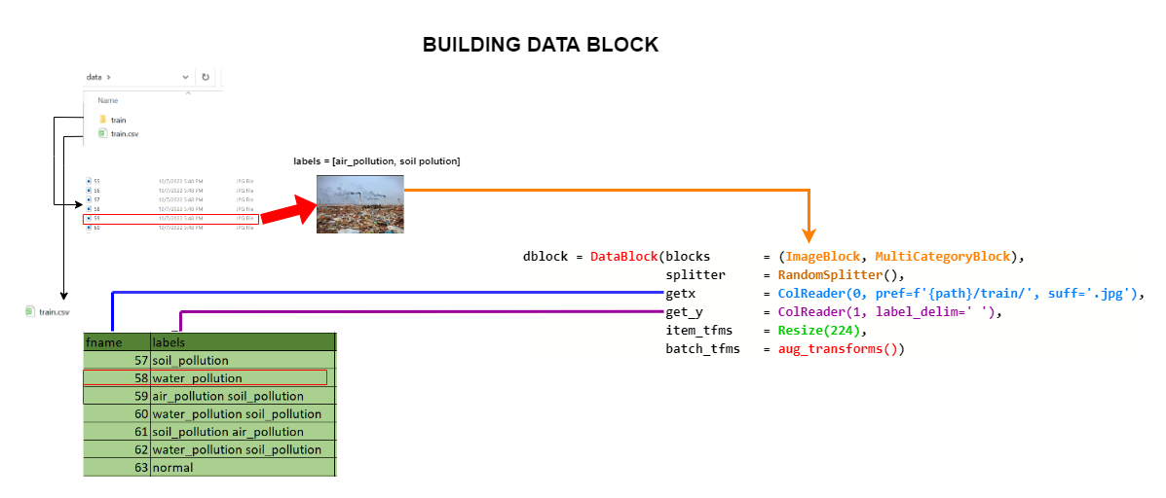

**Figure 3.** *Building Data Block*

A residual neural network (ResNet) is a convolutional neural network (CNN). Residual neural networks utilize skip connections, or shortcuts to jump over some layers. Typical ResNet models are implemented with double- or triple- layer skips that contain nonlinearities (ReLU) and batch normalization in between.[7]

There are two main reasons to add skip connections: to avoid the problem of vanishing gradients, or to mitigate the Degradation (accuracy saturation) problem; where adding more layers to a suitably deep model leads to higher training error.[7]

With the problem of image classification of which type of environmental pollution, choose the direction of Image Classification to solve. It is divided into 4 classes: soil pollution, water pollution, air pollution, and no pollution. Then prepare image data for each class and train the recognition model.

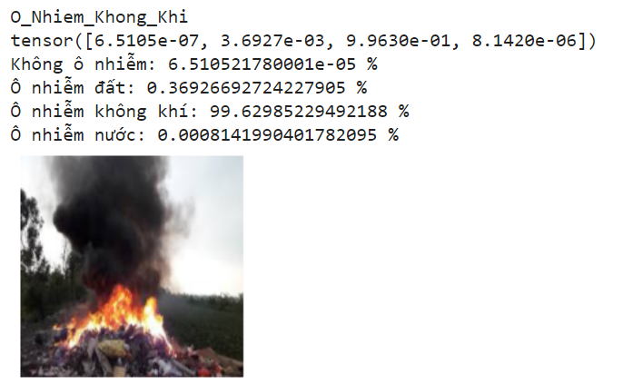

**Figure 4.** *Detect Pollution Using Multi-Class Classification*

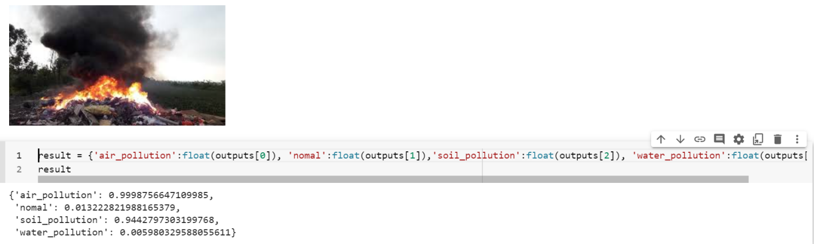

**Figure 5.** Detect Pollution Using Multi-Label Classification

The difference between Multi-Class Classification and Multi-Label Classification is that in multi-class problems, the classes are mutually exclusive. In contrast, for multi-label problems, each label represents a different classification task, but the tasks are related to each other. Here, we choose to handle the problem of Multi-Label Classification to be suitable for predicting many types of pollution in the same image.

## Technical Constraints

* **Technical to develop**
  + Language: Java (Spring Boot), Dart (Flutter), Python (Flask, FastAI)
  + Develop tool: Visual Studio Code, SpringToolSuite4
  + Version Control System: Git/GitHub
  + Database Management System: Oracle SQL Developer
* **Environment**
  + Operation systems: Microsoft Windows, MacOS, Android, iOS
* **Other Constraints**
  + Resource: 4 people.
  + Budget: Limited.
  + Time: The project must be completed within 04 months.
  + Area: Duy Tan University

# Current Status of Art

## Advantages

* No cumbersome and complex process: The application is very friendly for users to make a fast and effective pollution survey.
* No need to understand the complex environmental terms: The main focus of this system is for anyone who knows how to use the smartphone without a specialty in the environment area. Thus, no need to learn about complex environmental terms or you have to be an expert to use this system.
* Can detect multiple pollution types: With the application of AI, the system can discover multiple pollution types just by analyzing the submitted image by the user.
* Can automatically detect the location of pollution: Using location-based technology, there is no need for the user to specify the location where the pollution happens, everything will be automatic resolve.

## Disadvantages

* Image quality: The system will be based on the image to detect the pollution types of that craft village, so if the user has a phone with a low-quality camera could cause some problems when the AI tries to detect the pollution types.
* Internet connection issues: The system will use the internet connection to communicate with the database and other services. Thus, the area with no internet connection or an unstable internet connection could cause the system to stop functioning. This will problem can be fixed in the later phase of the project.
* Data validation: Sometime people will intend to input false informations, thus, it causes the system to contain false information. This will problem can be fixed in the later phase of the project.

# Engineering Approach

## System Context Overview

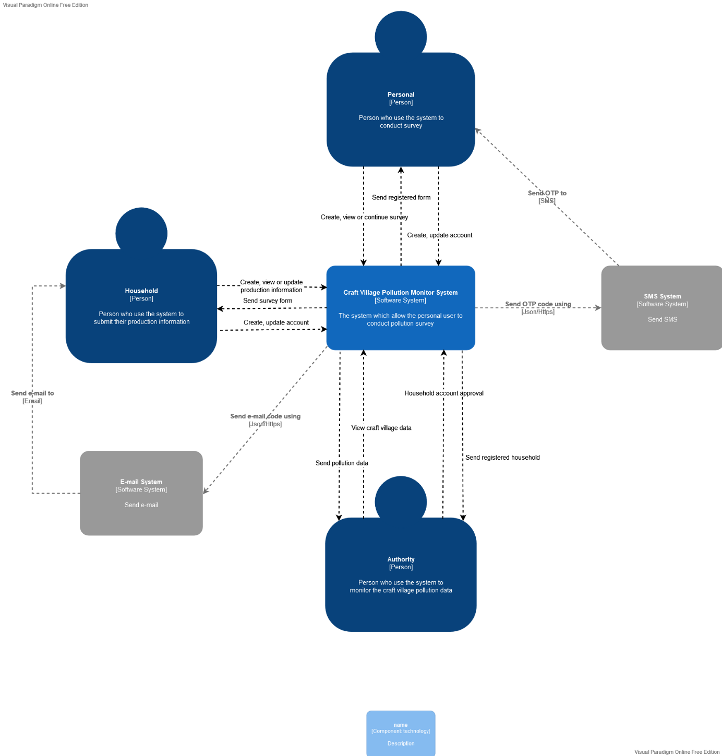

**Figure 6.** System Context Diagram

## System Context Description

* **As personal user, they can:**
* Create, update account from system.
* Create, view the pollution survey.
* **As a household user, they can:**
* Create, update account from system.
* Create, view production information survey.
* **As an authority user, they can:**
* View craft village data.
* Give approval for household new village request.

# Tasks and Deliverables

## Tasks and Scope

1. Proposal Document + Requirement Description Document
2. Project Plan Document
3. Product Backlog-User Story-Sprint Backlog Documents
4. Architecture Document
5. Database Design Document
6. Interface Design Document
7. Code Standard
8. Test Plan Document
9. Test Case Document
10. Meeting
11. Reflection

## Deliverables

1. Engineering report
2. Proposal
3. Design drawings
4. Design documents
5. Completed product (building, etc.)
6. Technical interpretation
7. Design review
8. Progress report
9. Improved process efficiency
10. Better customer service
11. Faster response time
12. Product prototype
13. User manual

# Project Management

## Scrum definition

Scrum is a subset of Agile and one of the most popular process frameworks for implementing Agile. It is an iterative software development model used to manage complex software and product development. Fixed-length iterations, called sprints lasting one to two weeks long, allow the team to ship software on a regular cadence. At the end of each sprint, stakeholders and team members meet to plan next steps.[2]

### **Scrum description**

* There are three specific roles in Scrum:
* **Product Owner:** The Product Owner focuses on business and market requirements, prioritizing all the work that needs to be done. He or she builds and manages the backlog, provides guidance on which features to ship next, and interacts with the team and other stakeholders to make sure everyone understands the items in the product backlog. The Product Owner is not a project manager. Instead of managing the status and progress, his or her job is to motivate the team with a goal and vision.[2]
* **Scrum Master:** Often considered the coach for the team, the Scrum Master helps the team do their best possible work. This means organizing meetings, dealing with roadblocks and challenges, and working with the Product Owner to ensure the product backlog is ready for the next sprint. The Scrum Master also makes sure the team follows the Scrum process. He or she doesn’t have authority over the team members, but he or she does have authority over the process. For example, the Scrum Master can’t tell someone what to do, but could propose a new sprint cadence.[2]
* **Teams working at scrum:** The Scrum Team is composed of five to seven members. Everyone on the project works together, helps each other, and shares a deep sense of camaraderie. Unlike traditional development teams, there are not distinct roles like programmer, designer, or tester. Everyone completes the set of work together. The Scrum Team owns the plan for each sprint; they anticipate how much work they can complete in each iteration.[2]

### The artifacts

* **Product Backlog**: The Product Owner and Scrum Team meet to prioritize the items on the product backlog (the work on the product backlog comes from user stories and requirements). The product backlog is not a list of things to be completed, but rather it is a list of all the desired features for the product. The development team then pulls work from the product backlog to complete during each sprint.[2]
* **Sprint Backlog**: is a list of functions developed for Sprint; it is determined by a Sprint Planning meeting. Sprint Backlog is the functionality selected from the Product Backlog based on priority levels and the ability of the team to develop.[2]
* **Estimation**: In SCRUM, members of the Task Team will be chosen by themselves and estimate the expected development time and be responsible for this estimate. After completing the table will update Sprint Backlog.[2]

### Process

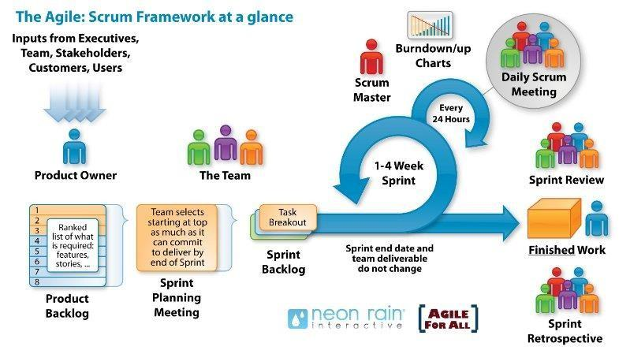

**Figure 7.** Scrum Framework at a glance

* **Sprint Planning meeting (planning meetings for each Sprint):** At the Planning meetings, the Team and Product Owner negotiate which items will be committed to the sprint. The team pulls the top items from the Product Backlog, commits them to the Sprint Backlog, breaks them into smaller tasks typically, and decides whether it’s the right amount of work for them to do and if they’re clear about what they are going to do. They plan one sprint.[2]
* **Daily Scrum Meeting (also called Stand-up Meeting):** Daily Scrum Meeting is meeting the recommended daily and no more than 15 minutes and standing meeting to ensure the meeting time is not extended at the beginning of each day.[2]
* If members are having problems, it should work individually to address and not take long for the members. Scrum Master to ensure this meeting is to comply with regulations.
* **Sprint Review:** A meeting to:
* Evaluate the results of the past Sprint and determine the Release function.[2]
* The function continues to modify or develop. Identify and discuss issues arising plan award decisions, additional Product Backlog.[2]

## Masterplan

**Table 1.** Master Plan

|  |  |  |  |  |
| --- | --- | --- | --- | --- |
| **No.** | **Task Name** | **Start** | **Finish** | **Effort** |
| **1** | **Initial** | **28/08/2022** | **29/08/2022** | **20 hrs** |
| 1.1 | Gathering Requirement Meeting |  |  |  |
| 1.2 | Analyze Requirement |  |  |  |
| **2** | **Create Document** | **29/08/2022** | **31/08/2022** | **22 hrs** |
| 2.1 | Create Project Plan |  |  |  |
| 2.2 | Create User Stories |  |  |  |
| 2.3 | Create Product Backlog |  |  |  |
| **3** | **Development** | **01/09/2022** | **07/12/2022** | **1040 hrs** |
| **3.1** | **Sprint 1** | **01/09/2022** | **15/09/2022** | **208 hrs** |
| **3.2** | **Sprint 2** | **18/09/2022** | **02/10/2022** | **208 hrs** |
| **3.3** | **Sprint 3** | **05/10/2022** | **19/10/2022** | **208 hrs** |
| **3.4** | **Sprint 4** | **22/10/2022** | **05/11/2022** | **208 hrs** |
| **3.5** | **Sprint 5** | **08/11/2022** | **22/11/2022** | **208 hrs** |
| **3.8** | **Review Project** | **07/12/2022** | **07/12/2022** | **6 hrs** |

## Cost/Budget For Project

**Table 2.** Total cost estimate

|  |  |  |  |  |
| --- | --- | --- | --- | --- |
| **No** | **Criteria** | **Price** | **Amount** | **Total (USD)** |
| 1 | Working hours | $ 2 | 1088 | $ 2176 |
| 2 | Online server and services | $ 50 | 2 | $ 100 |
| 3 | Party | $ 10 | 5 | $ 50 |
| **Total cost** | | | | **$ 2326** |

**Table 3.** Cost detail

|  |  |  |
| --- | --- | --- |
| **Description** | **Amount** | **Unit** |
| Number of members | 4 | Person |
| Number of working hours per day | 2 (During workday)  8 (During weekend) | Hour |
| Number of workdays / weeks | 7 | Day |
| The duration of the project | 3.5 | Month |
| Party cost per time | 10 | USD |
| The number of working days | 76 | Day |

# Project Contraints

**Table 4.** Project constraints

|  |  |  |
| --- | --- | --- |
| **Constraint** | **Constraints Description** | **Guidelines for Acceptance** |
| **Economic** |  | Elements for consideration are design costs, production costs, maintenance costs, operating costs, and sales price |
| **Environmental** | Our project makes the people (more precisely the craft villages) change the way their use material or energy to be eco-friendly, and sustainable. Thus, the living environment will be improved and reduce pollution. | The impact of the design on the environment as well as the impact of the environment (e.g. temperature range, humidity, vibration, electromagnetic interference immunity, and shock) on the design should be considered. Design for recycling and design to use recycled materials should also be considered |
| **Ethical** |  | Ethical considerations can be broad. Areas that are typically addressed include intellectual property, reverse- engineering, privacy, security, and the conflict between cost and safety |
| **Public health, safety, and welfare** |  | Includes safety standards as well as the impact of the design on users (for example, electrical or physical hazards) |
| **Social and Global** |  | Addresses aspects such as benefits, risks, the man-machine interface, the acceptance of products by the intended user or by society at large, and global and socially responsible engineering. |
| **Cultural** |  | Which cultural characteristics could influence the approach?  How do the design from different cultures differ? |
| **Sustainability** | Our project makes the people (more precisely the craft villages) aim to use more sustainable resources and save energy. Moreover, they could change the traditional way of manufacturing or the infrastructure into more eco-friendly ones. | Refers to the sustainability of resources, including material, energy, supplies, manufacturing techniques, personnel, operation, and the need for additional infrastructure, as well as the sustainability of the design including reliability, lifetime, durability, reusability, maintainability. |

# Conclusion

The pollution of the craft village is at an alarming rate, affecting the environment and people's lives. One of the main reasons for this happening is the lack of overseeing or the tools that help people to take part in the problem. Thus, with the urge to protect the environment and improve people's lives, our team would like to build a system that helps everyone to monitor the pollution from craft village quickly and effectively.

Our approach:

* We will build a phone application using Flutter that allows the user to make a pollution survey very quickly by taking a picture of pollution.
* The application will automatically attach the GPS location to the picture.
* The picture then will be sent to an AI that will analyze the picture to detect the pollution types.
* The result will automatically fill into the form for the user to check and submit.
* The local authority can use the system to monitor the data and know the pollution status of the craft village.

The project will be finished after the course of 4 months with a limited budget of 3000 USD.

# References

1. Nguyen Thi Loi, “[*Environmental pollution in Vietnam's craft villages*](https://www.e3s-conferences.org/articles/e3sconf/pdf/2020/35/e3sconf_interagromash2020_06012.pdf)*”,* National Economics University;
2. Kate Eby, “[*What's the Difference? Agile vs Scrum vs Waterfall vs Kanban*](https://www.smartsheet.com/agile-vs-scrum-vs-waterfall-vs-kanban)”, February 15, 2017;
3. Office of Water Prediction (U.S.), “[General Software Standards](https://www.weather.gov/owp/oh/hrl/developers_docs/General_Software_Standards.pdf)”
4. IEEE SA, “[Standard 12208-2017](https://standards.ieee.org/standard/12208-2017.html)”
5. NASA, “[LaRC Software Engineering (SWE) Process Improvement Initiative (SPII)](https://sw-eng.larc.nasa.gov/)”
6. Wikipedia, “[Location-based service](https://en.wikipedia.org/wiki/Location-based_service)”
7. Kaiming He, Xiangyu Zhang, Shaoqing Ren, Jian Sun, “[Deep Residual Learning for Image Recognition](https://arxiv.org/pdf/1512.03385.pdf)”
8. Wikipedia, “[Convolutional neural network](https://en.wikipedia.org/wiki/Convolutional_neural_network)”

# Attachment

1. C1SE.06_CVPMS_ReqDescription-Document_v1.0.docx